Title*: | MEC036 Use case Zero Defect Manufacturing
from Source*: | InterDigital, Inc., UC3M, NEC
Contact: | Debashish Purkayastha, Alain Mourad, Carlos Bernardos , Marco Liebsch
input for Committee*: | MEC
Contribution For*: | Decision | X
 | Discussion
 | Information
Submission date*: | 2020-07-23
Meeting & Allocation: | MEC#175-Tech -
Relevant WI(s), or deliverable(s): | DGR/MEC-0036ConstrainedDevice

Decision/action requested: Please approve

ABSTRACT: Use case on Zero Defect Manufacturing

1. Discussion
A new use case on Zero Defect Manufacturing is proposed. This use case is being addressed in the scope of multiple H2020 projects such as 5G-DIVE “eDge Intelligence for Vertical Experimentation” (www.5g-dive.eu) and 5GROWTH “5G-enabled Growth in Vertical Industries” (www.5growth.eu).

2. Proposal
The following changes are proposed.

First change

5 Use cases

5.1 Use case #1: Zero Defect Manufacturing

5.1.1 Description
This use case considers a production line in a smart factory. The production line is composed of machines that may be fixed or mobile (e.g. robots, robot arms, etc.) acting continuously or on-demand on the line. Additional sensors including video cameras are used for real-time monitoring and subsequent intervention by the machines, e.g. to stop the line or to remove a defective product. Such intervention by the machines is typically instructed/commanded by a remote factory worker acting upon real-time data received from the sensors and cameras over a local or wide area network (e.g. through a 5G network).
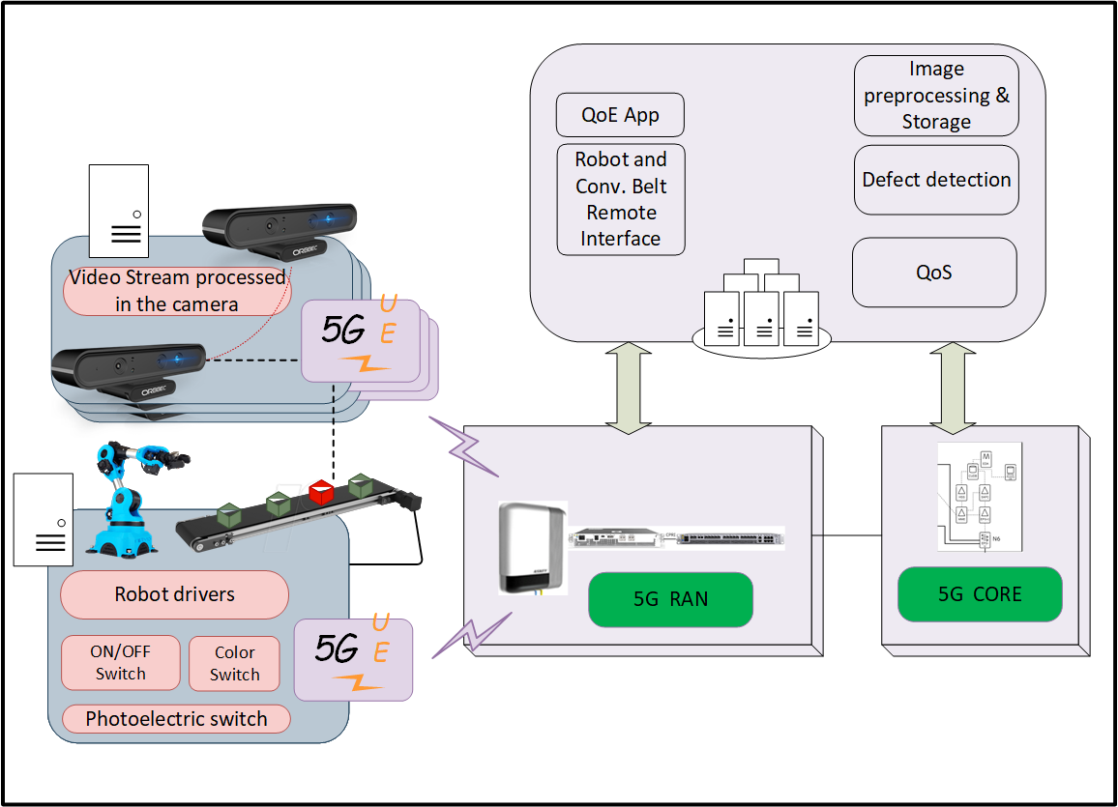

Figure x – Smart Factory of the future

The machines and devices in the smart factory are assumed to have capabilities for networking, computing, and storage. The computing capability on the local machines and devices in the factory can support distributed data telemetry and intelligent functionalities locally. Numerous cameras and sensors, with the possibility for some cameras to be on-wheels (e.g. carried by guided vehicles), are continuously monitoring the production line. These cameras and sensors are capable of data storage, fast data analysis, including extracting and capitalizing on the corresponding knowledge in real-time. Running Federated Learning across multiple devices allows fast and accurate data analysis. These functions help in detecting more efficiently and quickly characteristic patterns that allow the recognition of potential defects in the production line.

These local capabilities are leveraged together with additional (more sophisticated but mostly fixed) capabilities available in the end-to-end infrastructure (e.g. Telco Edge, Distant Cloud) connecting the smart factory to the remote digital worker.

Detection of a defective piece triggers a remote worker to command an intervention by some machines (e.g. robots or robotic arms) to stop the line or take the defective piece out of the production line to a certain destination. Such immediate intervention implies real-time processing and visualization of geometric features for manufactured parts at the remote worker location. Clearly the sooner a piece is detected as defective and taken out of the production line, the less scrap will be generated. Moreover, the faster the pieces are analysed, more pieces can be produced in each period.

End of change

