Title*: | MEC036 Update to Section 4 Overview
from Source*: | InterDigital, Inc.; University Carlos IIIde Madrid; NEC Europe Ltd
Contact: | Debashish Purkayastha, Alain Mourad, Carlos Bernardos, Marco Liebsch
input for Committee*: | MEC
Contribution For*: | Decision | X
 | Discussion
 | Information
Submission date*: | 2020-08-27
Meeting & Allocation: | MEC#175-Tech -
Relevant WI(s), or deliverable(s): | DGR/MEC-0036ConstrainedDevice

Decision/action requested: Please approve

ABSTRACT: Update to section 4 Overview, added a framework for describing the use cases

1. Discussion
Overview section is updated with clarification about a generic framework, which can be assumed for use cases related to edge computing in constrained devices.

2. Proposal
The following changes are proposed.

First change

4 Overview
The present document studies how terminal units, mobile hosts and personal devices can be used to support cloud computing at the edge.

Clause 5 documents the use cases that require edge computing on constrained devices, identifies requirements, analyse applicability of MEC specification and identify any gaps through Key Issues (KI).

Figure 1 illustrates the overall framework of the use cases considered. The framework consists of three logical layers, namely the network layer, computing layer, and application layer.

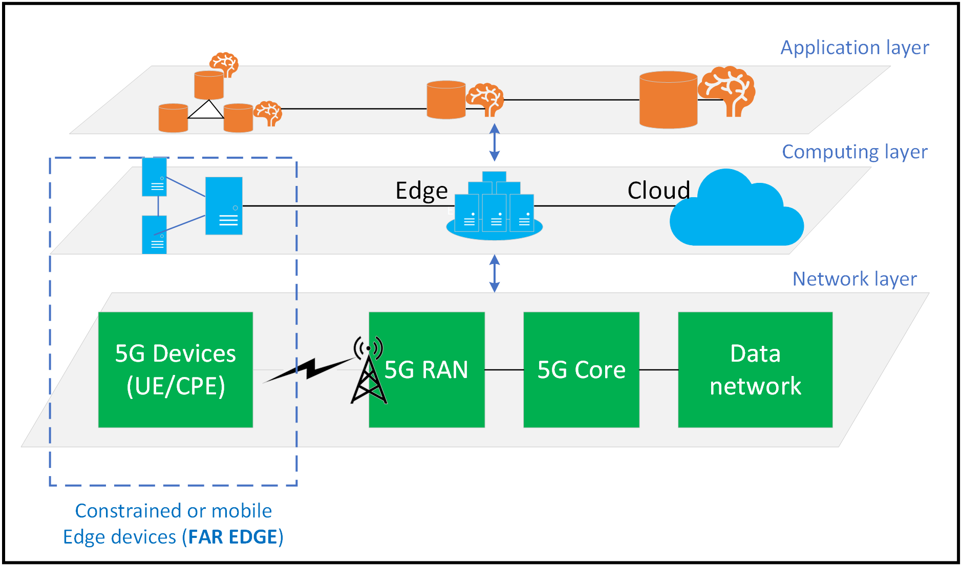
Figure 1: High Level Framework
The network layer is depicted using an end-to-end 5G network. The computing layer is composed of different computing tiers, namely, the central cloud, the edge cloud (e.g. Telco Edge) connected to network edge and far edge capabilities associated with the constrained devices (e.g. UEs or CPEs). Far edge capabilities may be embedded in the constrained terminal devices or provisioned externally. Constrained devices may be battery-powered, mobile, volatile, with limited compute and connectivity as compared to the traditional edge clouds. The constrained devices may collaborate and exchange information among themselves. The application layer, which may provide functionalities such as telemetry, training and inference, are envisioned to be distributed across different computing tiers, including far edge constrained devices. Applications and functions may be hosted anywhere in the computing stratum (cloud, edge or far edge devices).

Editor’s note: Some requirement might be commonly introduced by multiple use cases. Therefore, the rapporteur intends to summarize a list of gaps in the end of Clause 5 and treat corresponding solutions in Clause 6.

Clause 6 proposes the possible solutions for closing the gaps. Solutions are evaluated for feasibility and provide recommendation if there are multiple solutions.

Clause 7 finally concludes this study with recommendation for any future work.

End of change

